Lab1: Create policy from GCP console

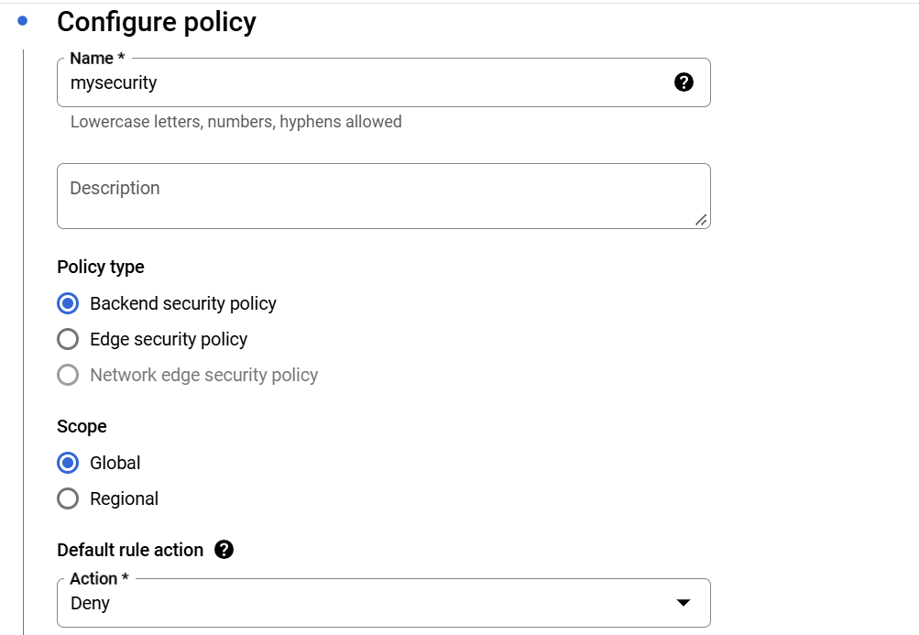

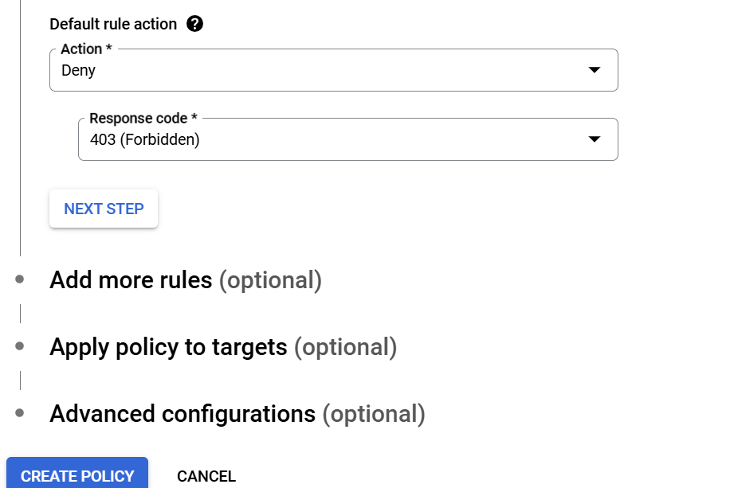

Setup the rules for the policy

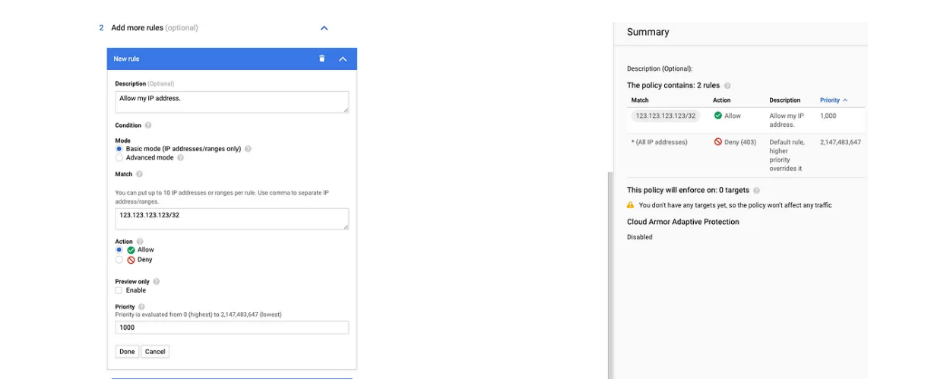

Lab 2 :The advanced mode is where you would create more complex rules by using logical operators, filter based on header values or referencing pre-configured rules (WAF).

'[CN, RU]'.contains(origin.region_code) || request.headers['user-agent'].contains('curl')

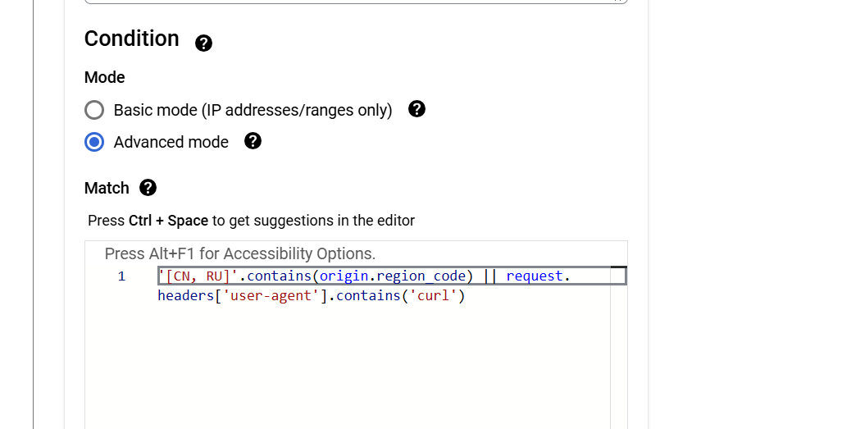

From the cli

gcloud compute security-policies rules add-preconfig-waf-exclusion *PRIORITY* \

--security-policy *POLICY_2* \

--target-rule-set "xss-v33-stable" \

--target-rule-ids "owasp-crs-v030301-id941140-xss" "owasp-crs-v030301-id941270-xss" \

--request-header-to-exclude "op=STARTS_WITH,val=abc" \

--request-header-to-exclude "op=ENDS_WITH,val=xyz"

gcloud compute security-policies rules remove-preconfig-waf-exclusion *PRIORITY* \

--security-policy *POLICY_3* \

--target-rule-set "sqli-v33-stable" \

--target-rule-ids "owasp-crs-v030301-id942110-sqli,owasp-crs-v030301-id942120-sqli"